Link to prototype: https://www.figma.com/proto/RPL0f2QJxO43FwXdt1Aabr/Workday-Project?node-id=0-1&t=sbH0gm11UjO4EogL-1

Timeline
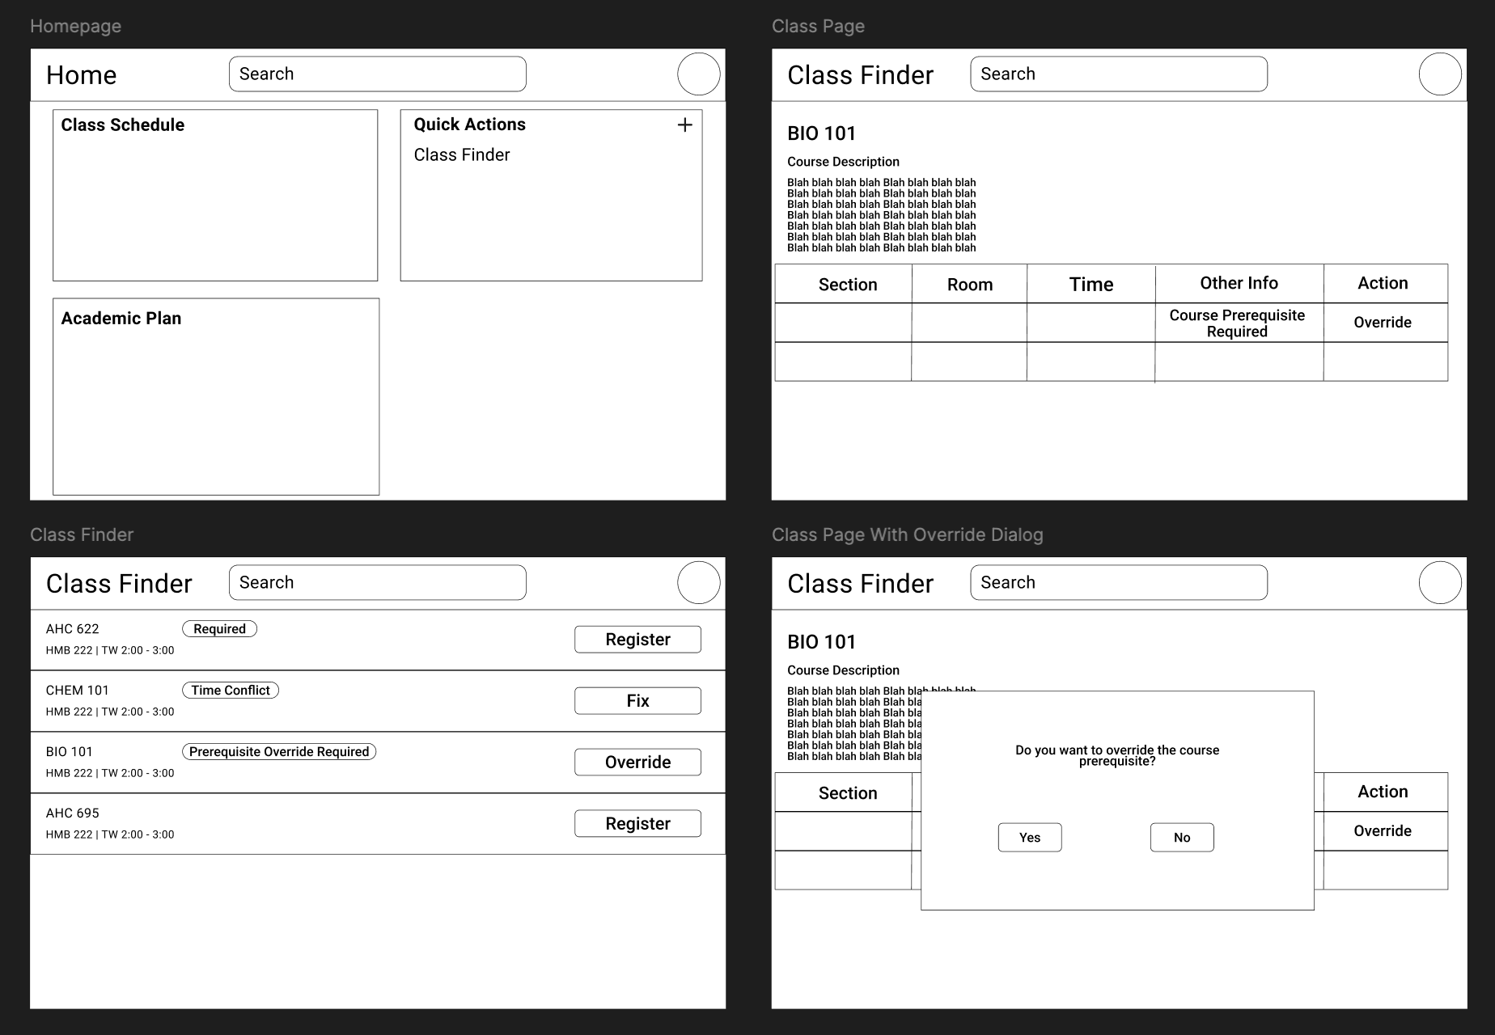
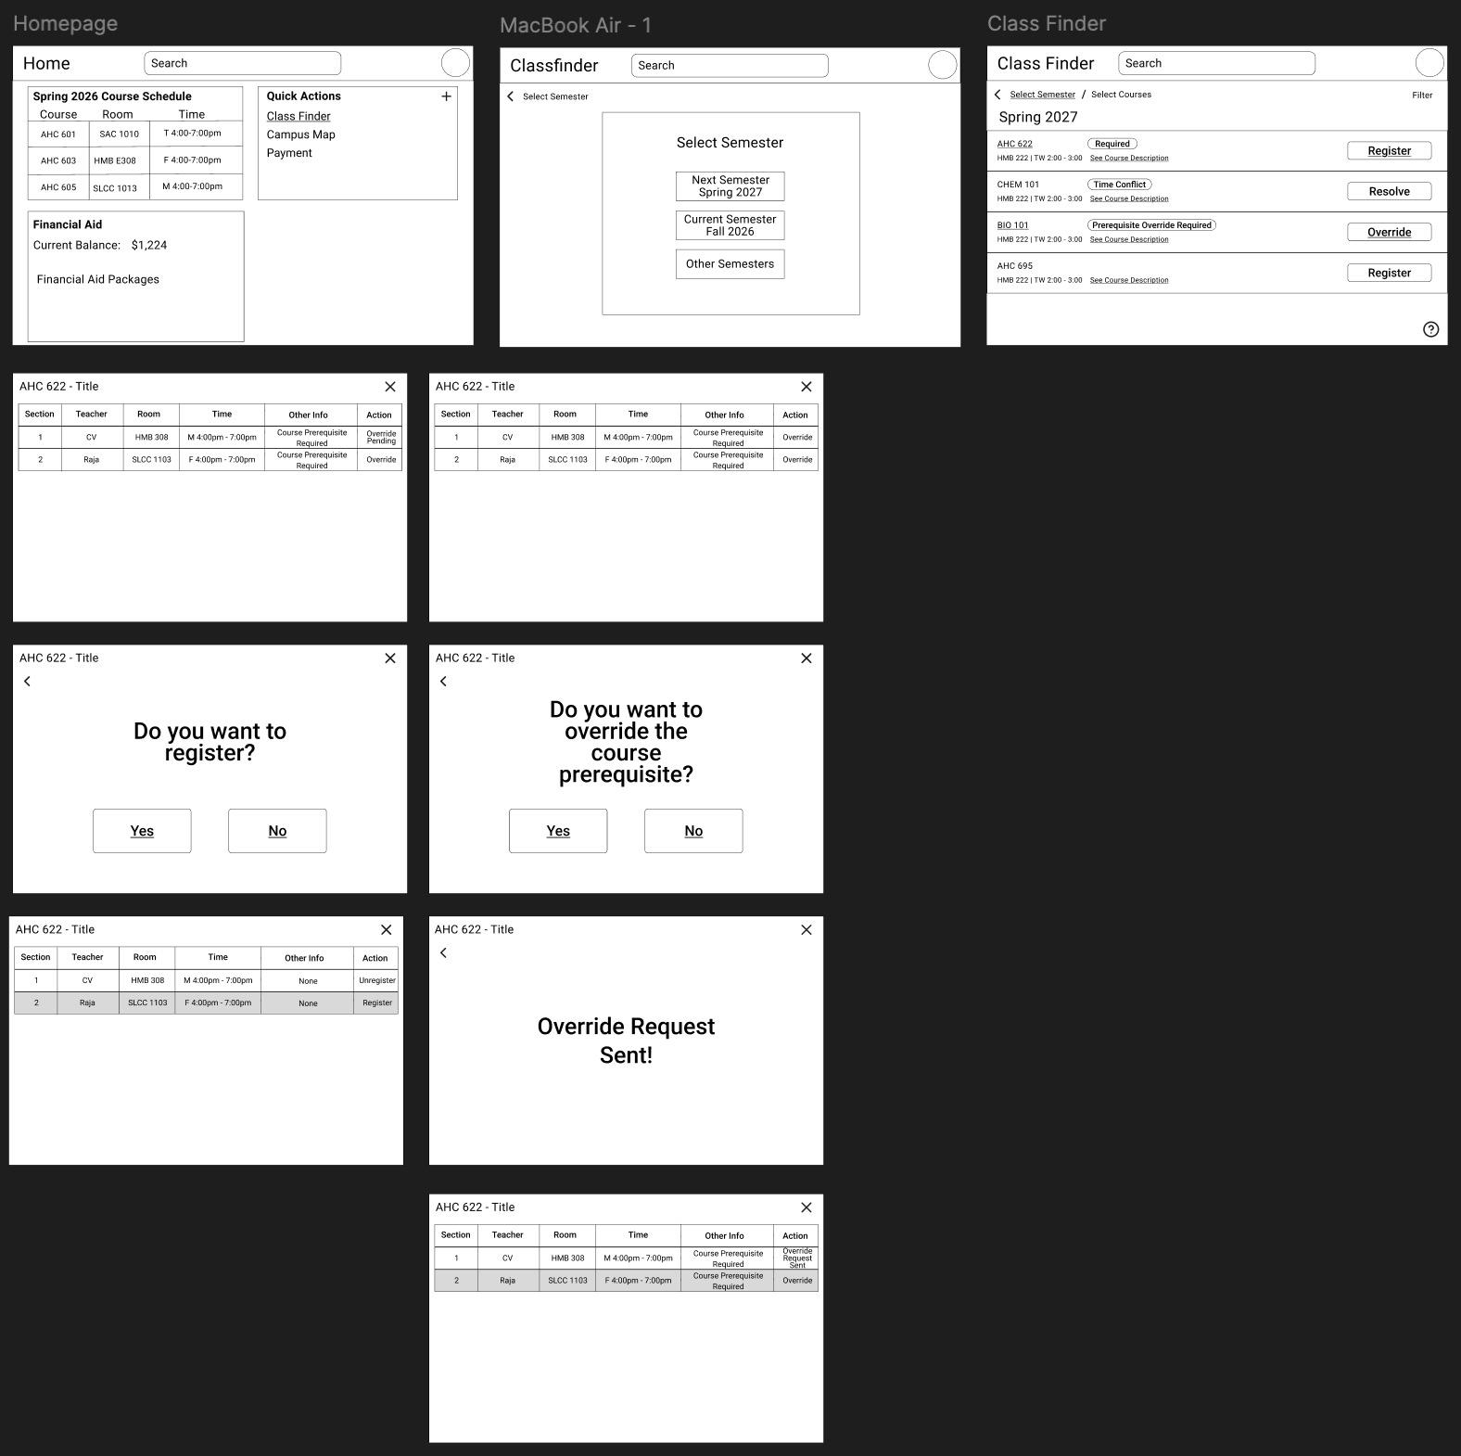
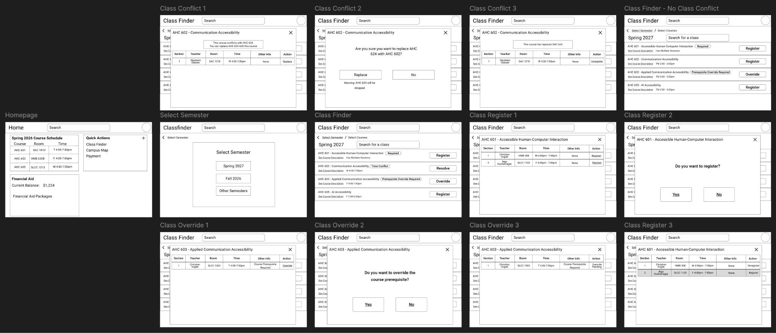
Final Low-Fidelity Prototype
